**Technical Documentation – Refresh_Penfax_Forms_Environments**

1. Workflow – Refreshes PENFAX Forms Environments from one environment to another.

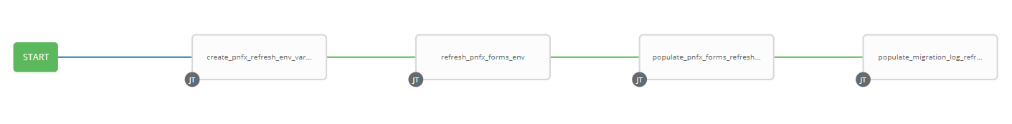

1. Extra Variables at the Workflow Level include the APEX/ORDS Migration Log URL

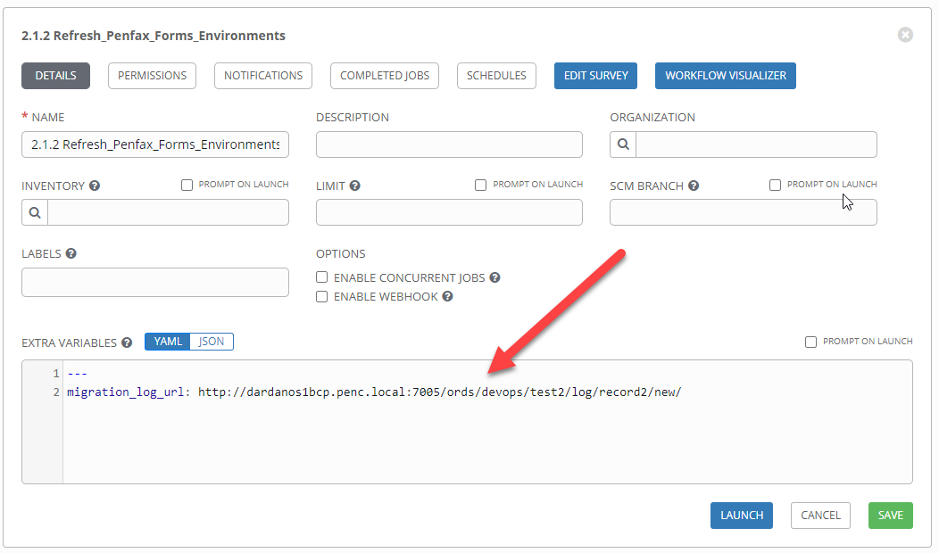

1. Survey – User Supplied Variables

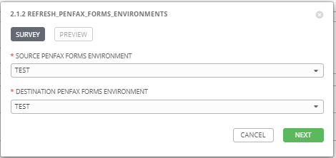

|  |  |  |  |
| --- | --- | --- | --- |
| **Survey Extra Variables** | **Prompt** | **Type** | **Description and Usage** |
| SOURCE | Source Penfax Forms Environment | Multiple Choice Single Pick | Environment to copy PENFAX Forms Artifacts FROM (TEST, MAINT). |
| DESTINATION | Destination Penfax Forms Environment | Multiple Choice Single Pick | Environment to copy PENFAX Forms Artifacts TO (DEV, TEST, MAINT, PROD). |

1. Jobs Used by the workflow - http://owl.penc.local:18080/svn/deploy_automation/trunk/Ansible_PlayBooks/FAR

| **Job Template** | **Ansible Playbook** | **Credentials / host** | **Project** | **Description and Usage** |
| --- | --- | --- | --- | --- |
| create_pnfx_refresh_env_vars | create_pnfx_refresh_env_vars.yml | None – runs on localhost as awx linux user | FAR Deployments | Source_Pnfx_Compile_Directory: "/export_home/codemove/compile/ipas12c/test_pnfx_rule"  Source_Pnfx_Runtime_Directory: "/opt/ipas_app_test/test_pnfx_rule"  stage_server: daulis1bcp  Tower_hostname: pdeploy1bcp.penc.local  far_server: daulis1bcp  Destination_Pnfx_Compile_Directory: "/export_home/codemove/compile/ipas12c/prod_pnfx_rule"  Destination_Pnfx_Runtime_Directory: "/opt/ipas_app/prod_pnfx_rule" |
| refresh_pnfx_forms_env | refresh_pnfx_forms_env.yml | Codemove on {{far_server}} typically daulis1bcp | FAR Deployments | Backs up the {{Destination_Pnfx_Compile_Directory}}, {{Destination_Pnfx_Runtime_Directory}} Directory and then copies in the {{Source_Pnfx_Compile_Directory}}, {{Source_Pnx_Runtime_Directory}}  If the Destination is a Development environment the file and directory attributes are opened up to chmod g+rwx to allow developers to update them. |
| populate_pnfx_forms_refresh_logs | populate_pnfx_forms_refresh_logs.yml | Codemove on {{stage_server}} typically daulis1bcp | FAR Deployments | If both the refresh_pnfx_forms_env job is successful populates the Log directory /codemove_common/dp_automation/refreshes/{{DESTINATION}}_Refesh_log.html file. |
| populate_migration_log_refresh_penfax | populate_migration_log_refresh_penfax | Pencmw on pdeploy1bcp/pdevops1bcp | FAR Deployments | Populates the migration log table utilizing the {{migration_log_url}} |